**5.4. Results**

Fig 5.9 shows the user interface of the system.It includes a simple form which the user has to fill in the initial process. The user has to fill the user id , and the name which will be saved in a csv file made by the system. When the user clicks on take images the system will take the images and then save it to the file structure assigned to him. Then when the user clicks on train images then model will be trained.

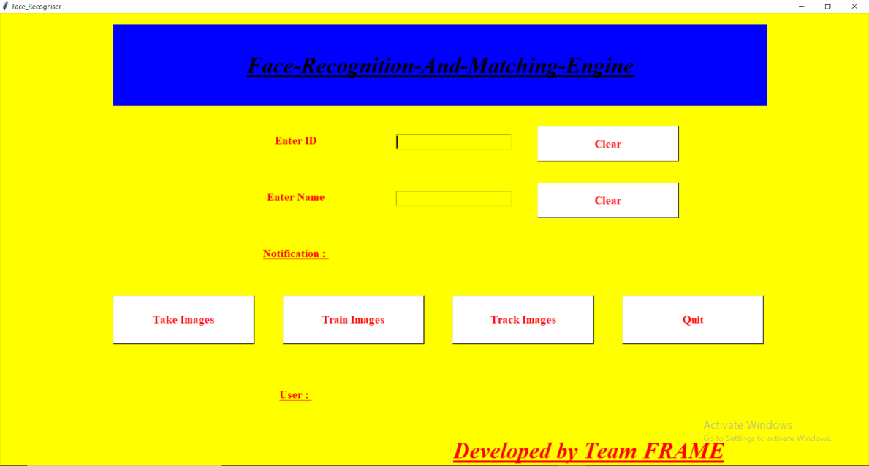

Fig 5.9 : UI of the present system

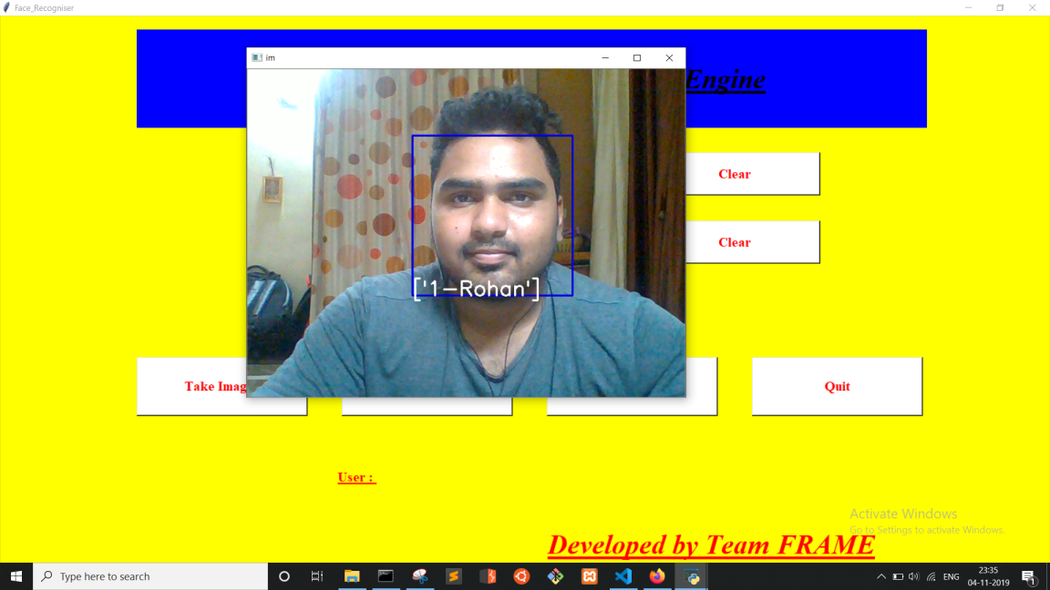

Fig 5.10 : Successful face recognition

Fig 5.10 shows how the system tracks an user who is registered, it also shows the bounded box around the user with his name, and id. It also saves the results in an csv file for logging the users.